Stucco Making

Pre-Lab Reflection Assignment

OVERVIEW

In this pre-lab activity, you will share your impressions of stucco to date, do basic research into its types and material composition, review how conservators and artists who use practice historical art techniques make stucco today, and evaluate the translated text of a sixteenth-century manuscript recipe for making stucco for molding. In lab, you will reconstruct this recipe.

PRE-LAB REFLECTION AND RESEARCH

- In your experience, what is stucco? Where have you encountered it? What associations do you have with it?

Navigate to the Conservation and Art Materials Encyclopedia Online (CAMEO) database: https://cameo.mfa.org/wiki/Main_Page. Search for “stucco.”

- Two types of stucco are described. Summarize the use and composition of each.

Navigate to YouTube and watch the following two videos:
- ZCZ Films, “Stucco: The Rococo's Secret Ingredient - Part 1,” YouTube, February 19, 2014, https://youtu.be/8_dwEbF-NiI?feature=shared.
- ZCZ Films, “Stucco: The Rococo's Secret Ingredient - Part 2,” YouTube, February 27, 2014, https://youtu.be/sROL5jpp-EI?feature=shared.

- List at least three specific things that you learned from these videos.

Consider the recipe “Stuc pour mouler” (“Stucco for molding”) on fol. 29r of manuscript BnF Ms FR 640, written down ca. 1580.

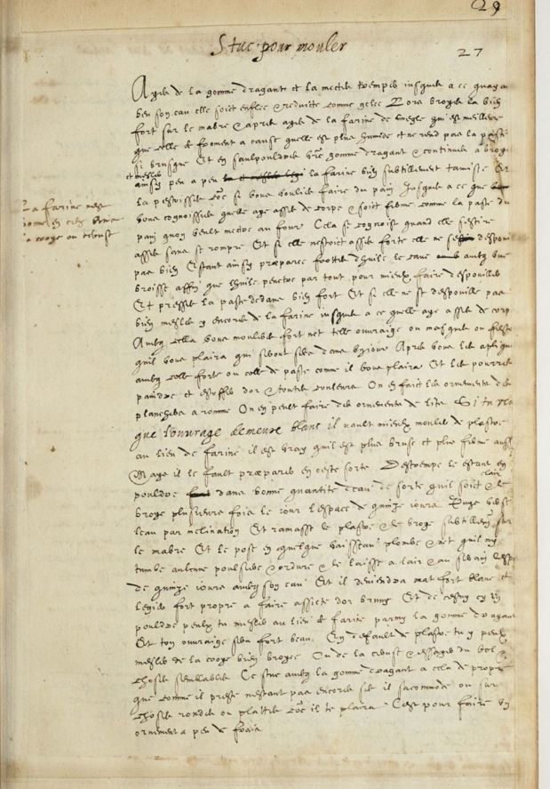
Translation, folio 29r
Stucco for molding
Take tragacanth gum and put it to soak until, having drunk its water, it is swollen & rendered like jelly. Then grind it quite hard on marble & next take rye flour, which is better than wheat because it is more humid and does not make the paste as brittle, and sprinkle your tragacanth gum with it, & continue to grind and mix in thus, little by little, it and mix legi the very finely sieved flour. And knead it as if you wanted to make bread, until you you perceive that it has enough body & is as firm as bread dough that one is ready to put in the oven. This is recognized when it can stretch enough without breaking. And if it was not strong enough, it would not sti release well. Once the paste is prepared, rub the hollow form at the u with oil, with a brush, in order that the oil penetrates everywhere to make it release better, and press the paste inside quite hard. And if it does not release well, mix in more flour until it has enough body. With this you will mold whatever work you like, masks or garlands, which will be dry within one day. Next, you will apply them with strong glue or paste glue, as you like, and you will be able to paint and decorate them with gold & all colors. One makes ceiling ornaments with it in Rome. One can make bed ornaments with it.
If you want that the work stays white, it is better to mold with plaster instead of flour. It is true that it is more brittle and firm as well, but one needs to prepare it like this: temper it, when it is powdered strong, in a good amount of water so that it is clear, & grind it several times a day for fifteen days. Then pour off the water by tilting, and gather the plaster & grind it finely on marble, & place it in some kind of clean lead vessel, so that no dust & dirt falls into it, & leave it in the open air & in the serain for fifteen days with its water, and it will become matte, strong, white and light, very suitable for making a seat for burnished gold. And this, in powder form, you can mix, instead of flour, with tragacanth gum, and your work will be very beautiful. Lacking plaster, you can mix in well ground chalk or ceruse, & try bole & similar things. This stucco with the tragacanth gum has the quality that, yielding when it is not yet dry, it can be accommodated on either round or flat things, as you like. It is to make an ornament at little expense.
At the top left margin: Flour is not good in this, but chalk or ceruse is.

- Read the manuscript entry carefully. There are several options for making the “stucco” described in the text. Write out a basic recipe and include any variants.

- Are the ingredients easily sourced? Where from? Provide links to your sources for this answer.

- What questions / concerns do you have heading into a lab reconstruction of this recipe?

